NIRMAYEE S. KADAM PRN-25070521134 SEC-C1
EX 6.1.1-INCREMENTED DATE

ALGORITHM:
- Input: day, month, and year.
- Check if year > 0.
- Check if month is between 1 and 12.
- Determine max days for the month (considering Leap Year for February).
- Check if day is between 1 and max days.
- If any check fails, print "Invalid Date" and stop.
- Increment Logic:
- New Year(If day =31 and month = 12)
  - Set day = 1, month = 1, year = year + 1.
- New Month(Else if day = max days:)
  - Set day = 1, month = month + 1.
- Next Day( Else:)
  - Set day = day + 1.
- Output: Print the updated day, month, and year.

NIRMAYEE S. KADAM PRN-25070521134 SEC-C1

FLOWCHART:
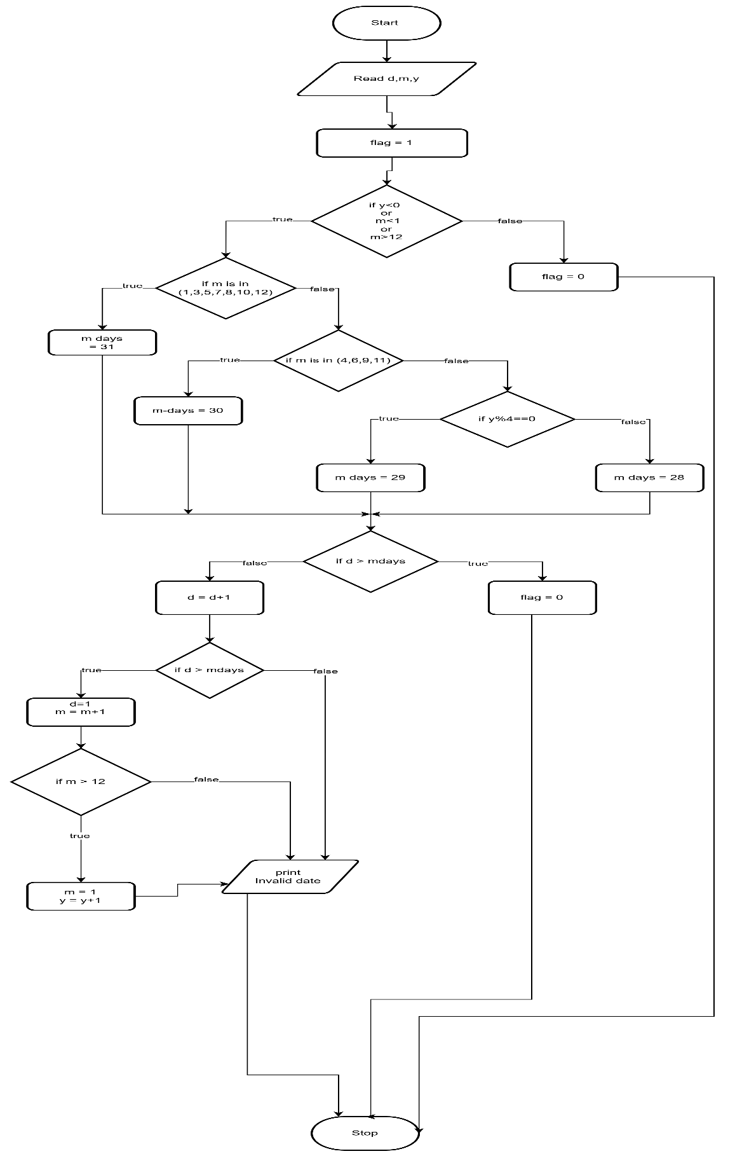

NIRMAYEE S. KADAM PRN-25070521134 SEC-C1

CODE:
